2D Barcode Scanner

User Guide

Version：1.0

NOTE：
- For stability enhancement of scanner or other properties, Manufacturer may modify the software (including firmware) .
- A standard packing includes a user guide, a cable and a Scanner .

Profile

It is developed to meet the increasing needs of 2D barcode identification. It does not only accurately and quickly read both 1D and 2D barcodes, but also seamlessly captures barcodes on electronic screens (such as mobile phone) and provides an effective data acquisition tool for e-coupons and e-tickets. It’s suitable for a wide variety of applications. Compared to the expensive imported scanners, It is definitely a cost effective and high performance product for you!

Parts of the Scanner
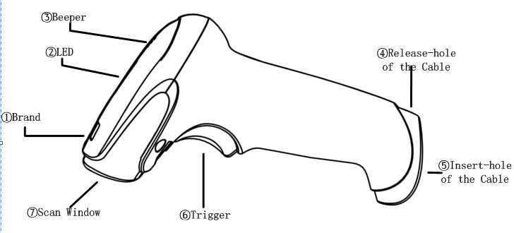

Performance index
Input voltage | DC 5V± 0.25V
Power | 1.40W（working） ；0.40W（standby）
Current | 400mA（Max）; 300mA（working） ；70mA（standby）
Image Sensor | 752 × 480 cmos sensor
Rotational Sensitivity | ±360°
Viewing Angle | ±40°
Symbologies | PDF417，QR Code，Data Matrix，HanXin code,Aztec,etc
 | Code 39, Code 128, Codebar, UPC, EAN, Interleaved 2 of 5, etc
Prompt | beeper，LED
Interface | USB VCP/USB HID
Trig mode | Hand-held/hand-free
dimension | L×W×H：190mm× 65mm× 85mm
Weight | 156g（without cable）
Cable | 2m
Connector | RJ-45
Material | PC
Temperature | -5°C~ 45°C（working） ；-40°C~60°C（Storage）
Humidity | 5%~95%（non-condensing）
Set mode | online/scanning
firmware update | online
Accuracy | ≥ 5mil
depth of focus | 40mm~300mm
security classification | EMC：EN 55022，EN55024  Electrical safety：EN 60950-1  Waterproof and dustproof：IP52

Installing the Cable
USB Cable
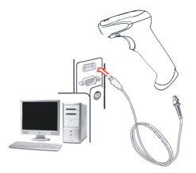
- Refer to the picture, connect the host with the scanner;
- Switch on the host. If the installation is successful, the beeper and LED will work.
- Scanner can work without External power supply.
- Host will automatically detect the scanner.
RS232 cable
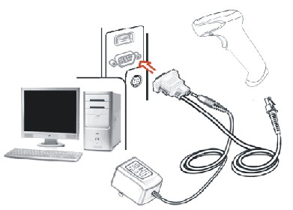
1、Make sure the power off。
2、Insert the RJ45 into the scanner。
3、Connect the RS232 to the host。
4、Plug the power adapter。
5、Power on the host. If connect right, it will prompt from beeper and LED.

Removing the Cable
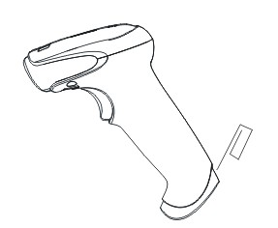

- Find the release-hole.
- Insert a thin wire into the hole and pull out the cable gently.

Parameter settings

Set from BarcodeSetTool
If the scanner is connected correctly, you can use the software of configuration management for the corresponding parameter settings 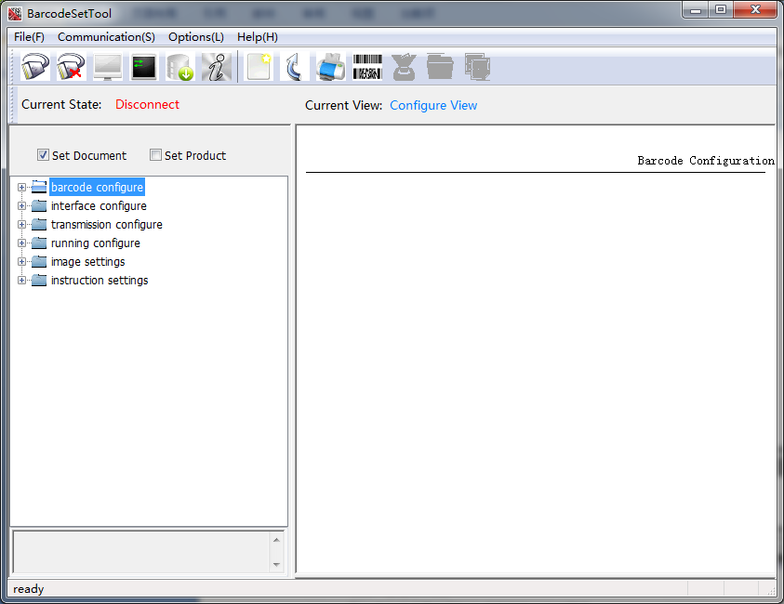

Please contact the local agency for the software.

Scan the barcode
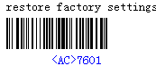
1.Single Setting
Scanning the corresponding 'set barcode'。
Example： Scan the right barcode，set ’sensing mode’。
2.Multiple Setting
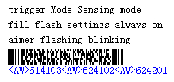
Reading ‘Multiple setting code’, You can perform a
variety of functions set.。
Example：Scan the right barcode，Set ‘Sensing mode’
‘Flash always on’ ’aimer flash blinking’
More ‘ Multiple setting code’, Please Contact local agents 。

Set up from the host
Note:
1 This section is suitable for the scanner with the RS232 cable or USB cable。
2 The scanner must be setup VCP mode for the USB type.
UART Parameters
（1） Baud rate:115200 bps;
（2） Data bits transmitted:8 data bits;
（3） stop bits:1 bit;
（4） parity check: NO;
3 protocols
Protocols command
Type | PID | FID | Parameter
1Byte | 1Byte | 1Byte | --
Instruction
Type | Length | Describe
TYPE | 1byte | Command type
PID | 1byte | Property ID
FID | 1byte | Function ID, FID as a parameter bytes instructions:：  7bit 6bit parameter length  0 0 No  0 1 1byte  1 0 2byte  1 1 >2byte
PARAM | -- | Parameter length according to FID。If the length is longer than two bytes, The first two bytes of parameters indicate the length of parameters.
Please contact the local agency for more information.

Scan
Hand-held Mode
- Ensure Scanner, Cables, and the Host are connected, then turn the unit Power ON；
- Press & hold Trigger. Illumination LED and Aiming LED cast an Illumination Pattern(red light)and an Aiming Pattern(green light)。
- On a successful reading, there will be a beep sound, illumination & aiming patterns die out. The scanner the transmits barcode message to the Host.
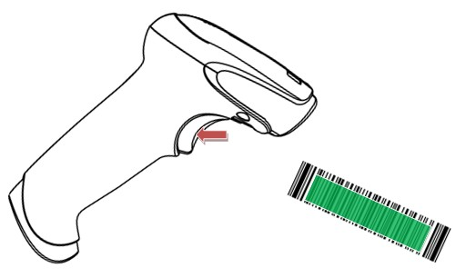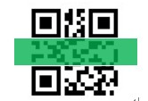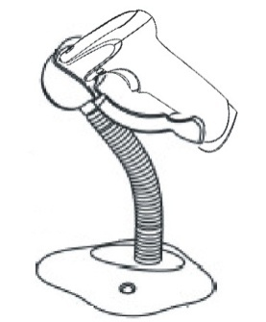

Hand-held Mode Hands-Free Mode

Hands-Free Mode
- Select reading mode ‘sensing mode’or’continuous mode’,when working in hands-free mode。
- Adjust the stand height for the optimum reading stance。

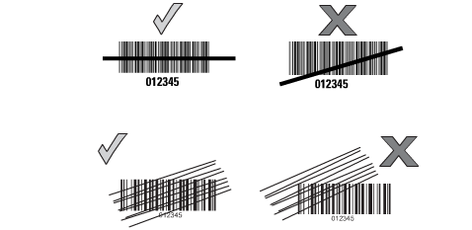

Beeper
Scanner through different buzzer to indicate status. It defines the different status in the following table.
Beeper | Instructions
2 short | Start
1 short | Success read

LED
Scanner also through different LED to indicate working status. It defines the different status in the following table.
LED | Instructions
OFF | Power off or standby.
Light for 1s | Success read

Setting Barcode

Instruction Settings
Restore factory settings
Start decoding Stop decoding
Disable all decoding Enable 1D decoding
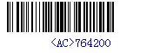
Enable 2D decoding Enable all decoding
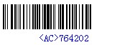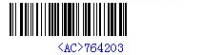

Barcode Configure

2D barcode settings
QR code enable QR code disable
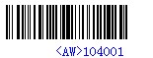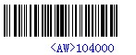

PDF417 code enable PDF417 code disable
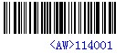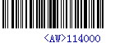

Chinese-sensible code enable Chinese-sensible code disable

DataMatrix code enable DataMatrix code disable
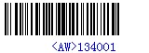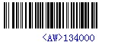

Aztec code enable Aztec code disable
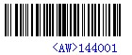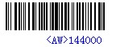

Code11 Configure
Code11 code enable Code11 code disable
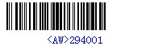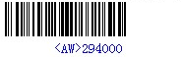

Check digit verification disable Check digit verification one digit
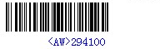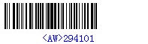
Check digit verification two digits Check digit verification auto
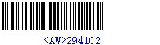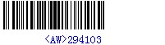

Code39 Configure
Code39 code enable Code39 code disable
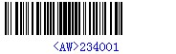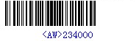
Code39 verification disable Code32 verification
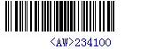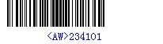

Code93 Configure
Code93 code enable Code93 code disable
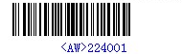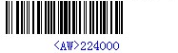

Code128 Configure
Code128 code enable Code128 code disable
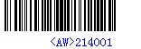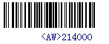

UPC Configure
UPC-A code enable UPC-A code disable
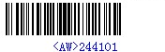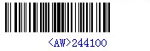

UPC-E code enable UPC-E code disable
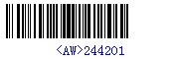

EAN Code Configure
EAN-13 code enable EAN-13 code disable
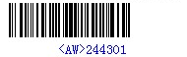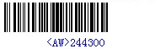
EAN-8 code enable EAN-8 code disable
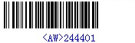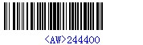

Codebar Code Configure
Codebar code enable Codebar code disable
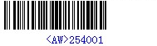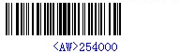

Codebar verification Enable Codebar verification Disable
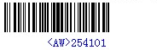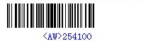

Standard 2 of 5 Code Configure
Standard 2 of 5 Code Enable Standard 2 of 5 Code Disable
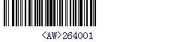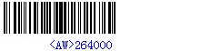
Verification Disable Verification Enable
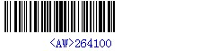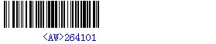

Matrix 2 of 5 Code Configure
Matrix 2 of 5 Code Enable Matrix 2 of 5 Code Disable
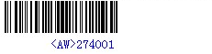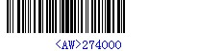

Verification Enable Verification Disable
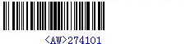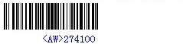

Interleaved 2 of 5 Code Configure
Interleaved 2 of 5 Code Enable Interleaved 2 of 5 Code Disable
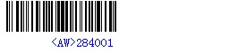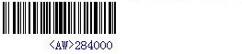

Verification Enable Verification Disable
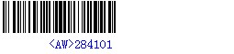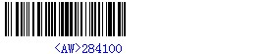

MSI Code Configure
MSI Code Enable MSI Code Disable
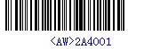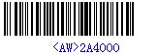

Verification Disable Verification Enable
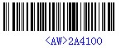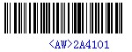

GS1 Databar Code Configure
GS1 Databar Omni-Directional Enable GS1 Databar Omni-Directional Disable
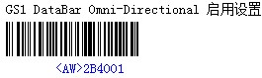

GS1 Databar Limited Enable GS1 Databar Limited Disable
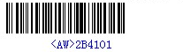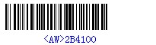

GS1 Databar Expanded Enable GS1 Databar Expanded Disable
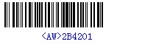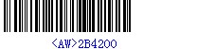

Plessey Code Configure
Plessey code enable Plessey code disable
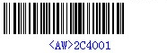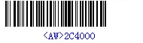

China Post Code Configure
China Post code enable China Post code disable

Interface Configure
Uart USB HID
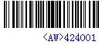

Uart baud rate 9600 Uart baud rate 19200
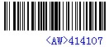

Uart baud rate 38400 Uart baud rate 57600
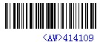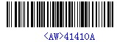
Uart baud rate 115200 Uart baud rate 12800
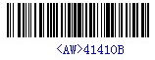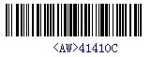
Uart baud rate 230400 Uart baud rate 25600
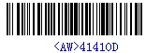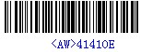
Uart baud rate 460800
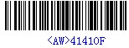
Note：Baud rate settings is set only for RS232 scanner. In VCP mode, baud rate is in Adaptive mode. You must set baud rate in 115200.

Transmission Configure
Prefix settings insert ‘tab’ Prefix settings insert ‘\r\n’
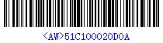

Suffix settings insert ‘tab’ Suffix settings insert ‘\r\n’
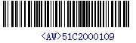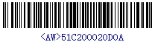

Symbology identifier enable Symbology identifier disable

Keyboard Layout
USA Spanish

German French
Italian Sweden
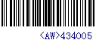
UK Brazil

Latin America India
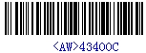
Korea Russia
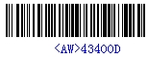

Running Configure

Trigger mode
Trigger mode Continuous mode

Automatic mode Sensing mode

Pulse mode
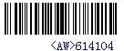

Auto sleep Settings
Auto sleep enable Auto sleep disable

Fill Flash Settings
Always off Blinking

Always on

Aimer flashing
Always off Blinking

Always on

Buzzer Settings
Low Volume Medial Volume
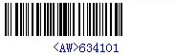

High Volume Buzz Num 0
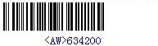

Buzz Num 1 Buzz Num 2
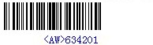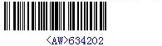

Troubleshooting
Problem | Possible Cause | Possible Solution
Scanner does not turn on | Power off | Insert the adapter.
 | Interface fails | Check the cable.
Scanner power on, but it cannot read the barcode. | Did not enable the barcode | Please enable it.
 | Scanner cannot read the barcode type. | Please contact the dealer or us
 | Wrong distance. | Move the scanner.
Scanner does not send data to host computer | Scanner is not connected to the host. | Check all cable to host computer.
Receive garbled with RS232 | Scanner and the host baud rate settings are inconsistent | Check scanner an PC communication port baud rate settings are the same.

