Firmware upgrade
Step1. Connect the R7 Ring Scanner with PC via micro-USB and open the power.
Step2. Open the upgrade program ‘Update_V1.5.2_EN.exe’
Step 3. Scan the following barcode to activate R7 into the update mode.
Step 4. Select the bin file-V3.8 and choose USB update.
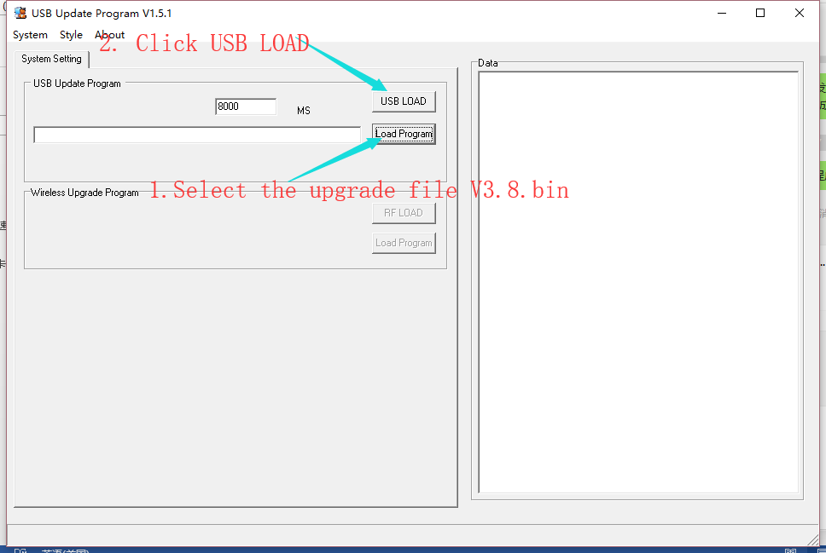
Step 5. Waiting for completion.
