CONTENTS
Contents I
Version Information IV
一、 Basic Information 1
(1) Factory Configuration 1
(2) Save current configuration as default configuration 1
(3) Default configuration(Customer configuration) 1
(4) Setting code switch 1
(5) Product information 2
二、 Communication interface 2
1. RS232 2
（1）Baud rate 2
（2）Odd and even check bit 4
（3）Stop position 4
2. USB KBW 4
3. USB COM keyboard 5
三、 Read mode 5
1. Manual mode 5
2. Continuous mode 5
（1）Read interval length 6
3. Induction mode 6
（1）Stable induction time 6
（2）Sensitivity level setting 7
4. Host mode 7
5. Single scan duration单次扫描时长 7
6. The same code reading time interval 8
四、 Lighting and aiming 8
1. Lighting 8
2.Aiming 9
五、Output instruction 9
1. Keyboard Languages Settings 9
2. Beep sound 12
（1） Mute mode 12
（2） Volume level 13
（3） Decoding success tone 13
（4） Power on tone 13
（5） Setting code tone 14
3. Decoding status prompt 14
4. Keyboard output force letter case conversion 15
5. Data encoding format 15
6. VAT invoice automatic identification output function 16
六、Data editing 16
1. Barcode ID 16
2. End character 17
3. Add suffix 18
4. Add multiple suffixes 19
5. Hidden character 21
（1） Hide header data 21
（2） Central data hiding 22
（3） Hide tail data 23
七、Barcode types enable/disable setting 23
1. 1D code overall enable switch 23
2. 2D code overall enable switch 24
3. code reading in reverse 24
4. UPC-A 24
5. UPC-A additional code 25
6. UPC-E 26
7. UPC-E additional code 26
8. Transfer UPC-E to UPC-A 27
9. Transfer UPC-A to EAN-13 28
10. EAN-8 28
11. EAN-8 additional code 29
12. EAN-13 30
13. EAN-13 additional code 30
14. CODE 128 31
15. GS1-128 31
16. ISBT-128 32
17. Interleaved 2 of 32
18. Matrix 2 of 5 33
19. Industrial 2 of 5 34
20. Standard 2 of 5 35
21. Code 39 36
22. Code 39 Full ASCII 37
23. Code 32 37
24. Code 93 38
25. Code 11 38
26. Codabar 39
27. PLESSEY 39
28. MSI 39
29. GS1-Databar 40
30. ITF14 40
31. QR Code 41
32. Data Matrix 42
33. PDF 417 43
34. Aztec code 45
35. Maxi code 45
36. Hanxin code 45
Appendix 1：digital setting code 46
Appendix 2：cancel barcode 48
Appendix 3：Code ID 48
Appendix 4：character comparison table 49

Version information
Version | Date | Description
V00 | 2015-06-12 | The first version
V01 | 2015-10-25 | Delete invalid content
V02 | 2016-12-26 | Add some scan configuration features
V03 | 2018-01-01 | Improve some configuration features
V04 | 2018-05-04 | Improve some configuration features
V05 | 2018-08-03 | Add multiple prefix and suffix functions
V06 | 2018-08-016 | Add character hiding  Add save current configuration to default configuration
V07 | 2018-08-018 | Add customer configuration code

User settings manual

Basic Information

Factory Default
way of communication：USB KBW
Trigger mode：Button hold
Terminator：Enter(\r)。

Factory Default

Save current configuration as default configuration
Users can set the configuration as required according to the usage environment.Then scan saves the current configuration as the default configuration, and the settings become the default settings (customer configuration)

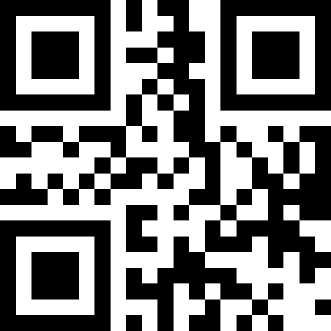
Save current configuration as factory default

Default configuration(customer configuration)
When the user sets the default settings (customer configuration),scan the default configuration (customer configuration), all can be restored to the original customer configuratio
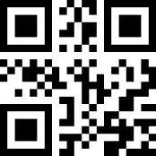

Default configuration(customer configuration)

Setting code switch

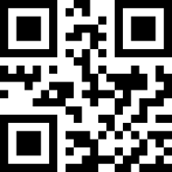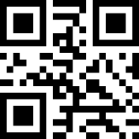
*ON OFF

Product information

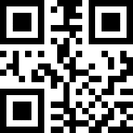

Communication interface

RS232
Serial communication interface is a common way to connect the reading module to the host device (such as PC, POS, etc.).When the reading module is connected to the host using a RS232 cable,the system defaults to serial communication mode.When using the serial communication interface,the reading module and the host device must be completely matched in the communication parameter configuration to ensure smooth communication and correct content.Related configuration of RS232 is:9600 baud rate,8-bit data,no check digit,1 stop position.
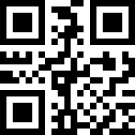
TTL 232 interface

（1）Baud rate
When the engine and the host can communicate with TTL/RS232,the same communication parameters must be set to communicate properly, including transmission rate, parity, flow control, and so on.The transmission rate is the baud rate and the default baud rate is 9600.
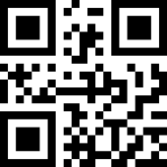
1200bps
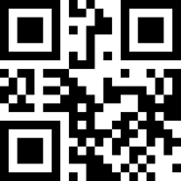
2400bps
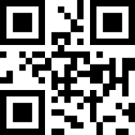
4800bps
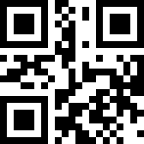
* 9600bps
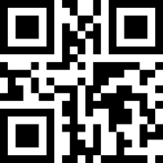
19200bps
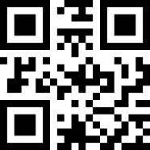
38400bps
57600bps
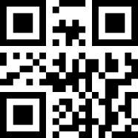
115200bps

（2）Odd and even check bit
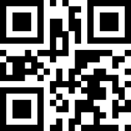
Odd
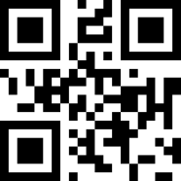
Even
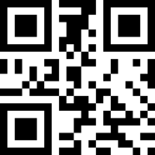
No check digit

（3）Stop position
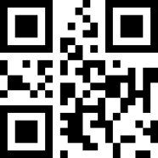
* 1 stop position
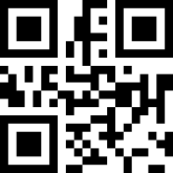
2 stop position

USB KBW
When the reading mode is connected to the host using the USB cable, the reading mode can be configured as a standard keyboard by scanning the USB KBW setting code.
USB KBW keyboard

USB COM keyboard
When the reading mode is connected to the host using the USB cable, the reading mode can be configured as a virtual serial port output mode by scanning the USB COM setting code.
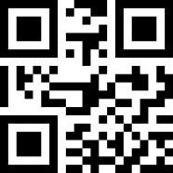
USB COM

Reading mode

Manual mode

（1）Button hold mode
Set to the button hold mode, press the button to trigger the reading, release the button to end the reading. The reading is successful if the reading is successful or the reading time exceeds the single reading time.
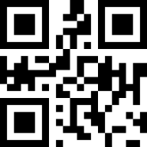
*Manual mode-button hold mode

（2）Button trigger mode
Set to the button trigger mode, press the button to start reading, release the button to read will not stop, read successfully or read more than a single reading time to stop reading
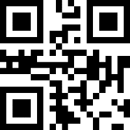
*Manual mode-button trigger

Continuous mode
Set to continuous mode, no triggering is required, the reading mode immediately starts reading the code, the reading is successful or the reading time exceeds the single reading time to end the reading, and the next reading is automatically triggered.
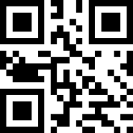
Continuous mode

（1）Reading interval length
The interval between two readings in continuous mode. Regardless of the success or failure of the last reading, it will automatically enter the next reading after that time.
Default：500ms，unit：100ms，range：0-9900ms
Set the reading interval by scanning the barcode,for example：
Setting 0.5ms,scan the barcode below first, then scan the barcode “0” and “5” of the digital setting code.
Reading interval length

Auto-sensing Mode
In the auto-sensing mode, the recognition engine detects the brightness of the surrounding environment. When the brightness changes, it triggers the reading, the read success or the recognition time exceeds the single reading time to finish the reading. Whether successful or failed in the last reading, re-enter the detection of the brightness of the surrounding environment
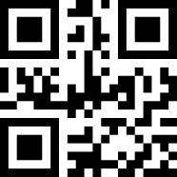
Auto-sensing Mode

（1）Stable Induction Time
Stable time before entering the test environment, default: 500ms, unit: 100ms, range: 0-9900ms
You can set a stable induction time by scanning a bar code, example:
for 200ms，to scan following code, then scan numeric code “0”and”2”
for 1500ms，to scan following code, then scan numeric code “1”and”5”

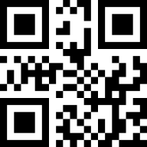
Stable Induction Time

（2）Sensitivity rating setting
There are three levels of sensitivity to choose, default: high sensitivity

*High
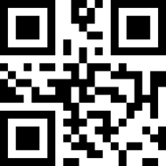
Middle

Low

Host Mode
Through instruction trigger reading engine read, you can finish reading by instruction, or you can finish reading if you read successfully or more than one read.。

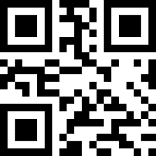
Host Mode

Single Scanning Duration
This parameter is the duration of a single decode, with a setting range of 0.5 to 25.5 seconds and a step of 0.1 seconds. The default duration is 3 seconds. If you want to set it to a different length, you can scan the bar code below. Scan the 3 digit settings code in the appendix to set the required time, less than 3 bits are offset with 0.
ou can set a stable induction time by scanning a bar code, example:
For 0.5s，to scan following code,then scan numeric code “0” and “5”.
For 10.5s，to scan following code,then scan numeric code “1”,”0” and “5”.
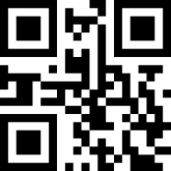

Single Scanning Time
6.Same Read Time Interval
The same reading time interval refers to read a bar code, within a set period of time, refuse to read the same bar code. Only after more than the length of time, you can read and output. Default: 500ms, step: 100ms, range: 0-9900ms, mainly for continuous mode and automatic induction mode.
You can set the same read time interval by scanning the bar code. Example:
For 0.5s，to scan following code,then scan numeric code “0” and “5”.
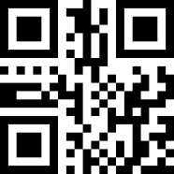
Same Read Time Interval

Lighting and Aiming

1. Lighting
Lighting could provide supplementary lighting for shooting to read, when light beam illuminate reading aim,to improve reading ability and adaptability in weak ligh. The user could set it to one of the following states according to the application.
Normal（Factory Default） ：The light is on when shooting to read, off in other time.
Always light：The lights keep glowing after reading module is on.
No Light：The lights don’t light up in any cases。
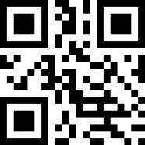
* Normal
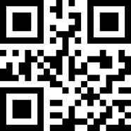
always Light
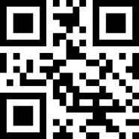

No Light

2.Aiming
Aiming beam could help users to find the best reading distance when shooting to read. The user could choose one of the following states according to the application. Normal（Factory Default） ：Reading module project aiming beam when shooting to read
Always Light：After reading module power on, always project aiming beam
No Light：Aiming beam is off in any case
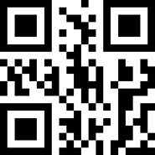
* Normal (Flicker) Always Light (No Flicker)

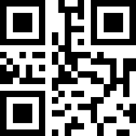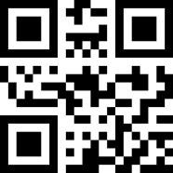
Always Light No Light

五Output Instruction

Keyboard Languages Settings
When the engine is recognized as a keyboard input device, some of the input characters vary from country to country, and different languages are required. The keyboard defaults to USA English.
* USA
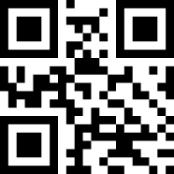
Belgian
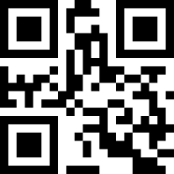
Finland

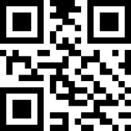
France

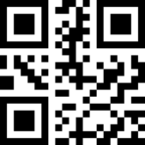
Germany

Italy

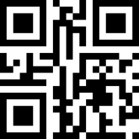
Sweden

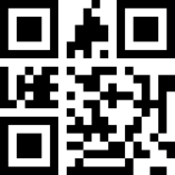
UK

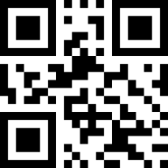
Denmark

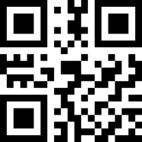
Norway

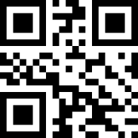
Spanish
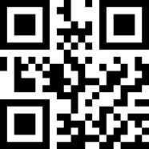
Portugal
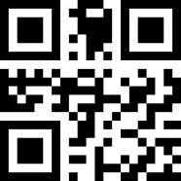
Turkey F

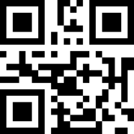
Turkey Q
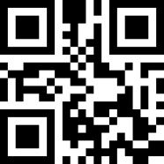
Japan

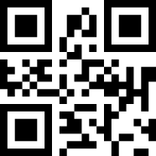
Russia

Warning Tone

Silent Mode
Turn off or disable all cues, scan the corresponding bar code below 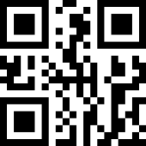
Disable all cues
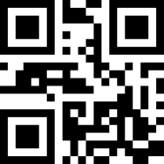
*NO-Disable ALL Cues

Volume Level
There are three levels of volume to choose, Default: High
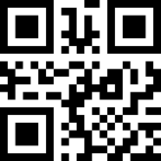
*High
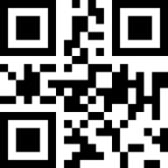
Middle
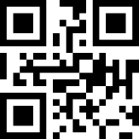
Low

Decoding successful prompt Tone
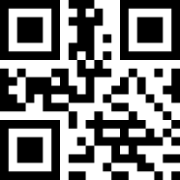
*ON
OFF

Boot Prompt Tone
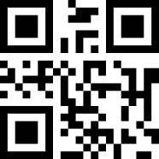
*ON
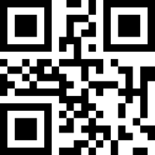
OFF

Setting code Prompt Tone
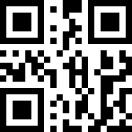
*ON
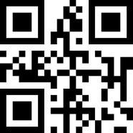
OFF

Decoding Status Prompt
If the barcode cannot be decoded during the timeout before releasing the trigger button, it is allowed to send unread messages. Any feasible prefix or suffix can be attached to this message
When this function is disabled, you cannot send any messages to the host even if the bar code cannot be decoded.
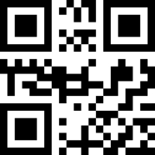
*Disable Transmitting NR
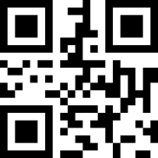
Enable Transmitting NR
3. Keyboard Output Forced Letter Case Conversion
Keyboard alphabetic conversion. When you output a bar code with letter content, you can configure the output to be all uppercase or lowercase. For example, if the bar code is: ab123de, if "converted to uppercase" bar code, output result is: AB123DE; if sweep "convert to lowercase" bar code, output result is: abc123de; default keyboard is case-insensitive. 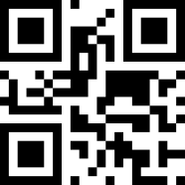
*Disable

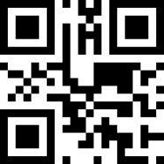
Uppercase
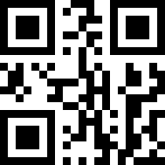
Lowercase
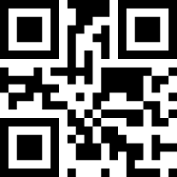
Case Reverse

Data Coding Format
In order to enable the host to print Chinese data in the specified encoding format, it can be set by reading the data encoding format.
0: Primitive Type,
1:GBK(GB2312),suitable for notepad excel and other software display.
2:UNICODE,,suitable for WORD,QQa and othe software display.
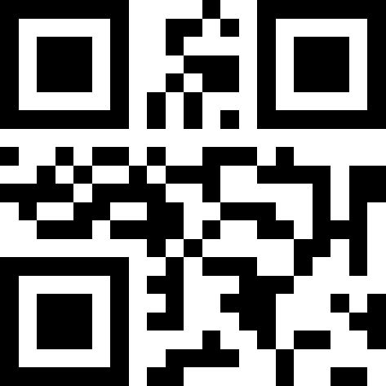
Primititive Type
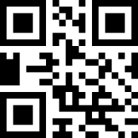
*GBK Data Coding Format

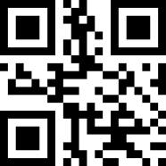
Unicode

Value added tax invoice automatic identification output function
Enable

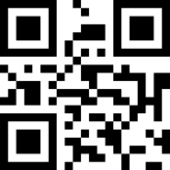
*Disable

六、Data Edition

Code ID
Users can use code id to identify different barcode types, each barcode type corresponding to the code id using a character for identification, see appendix 3.
*No-permitted Transmitting ID
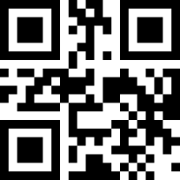
Permit Transmitting ID

Ending Character
The terminated character is to add the character format after decoding data: Decoding Data+Character Terminated。
*No Ending Character
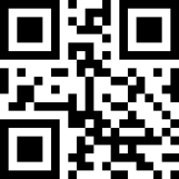
# & CR LF
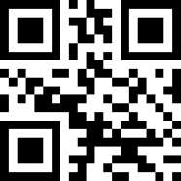
% CR
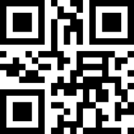
TAB
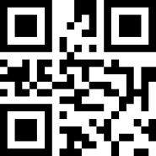
CR CR
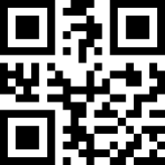
CR LF CR LF

Prefix&Suffix
- Setting Code
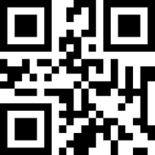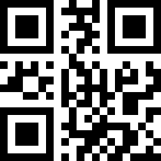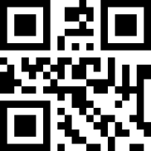
Peffix Suffix一 Suffix二
- Define Preffix and Suffix Content
A prefix or two suffixes can be attached to scanned data for data editing. Set these values to scan a four-digit number (that is, four bar codes) for the ascii value.
For example：The corresponding value of the letter A is 1065, and the digit codes are scanned in sequence 1065, as shown in Appendix 4: Character Control Table and Appendix 1: Number Setting Code
Scan the following settings code to set the expected data transfer cell 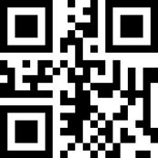
*Initial Data
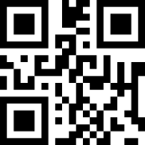
Prefix+data
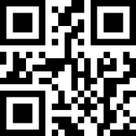
Data+Suffix1

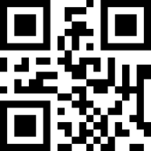
Prefix+data+Suffix 1
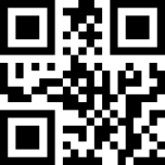
Data+Suffix 1+Suffix 2
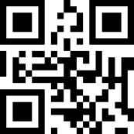
Prefix+Data+Suffix 1+Suffix 2

Add Multiple Suffix
- Prefix
- To scan this code below
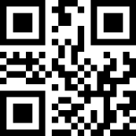
Continunous Setting of Multiple Suffix
- Scan the numeric settings code in turn, with one successful tone for every four
(3)Scan “ Finish Setting multiple Prefix&suffix” setting code, ending the settings
Finish Setting multiple Prefix&suffix

*Suffix (similar to a prefix, if you need LF, you can add it on the suffix)
（1）to scan” Multiple Suffix Setting Code”
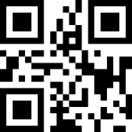
Multiple Suffix Setting Code
（2）setting Prefix&suffix
（3）Scan “ Finish Setting multiple Prefix&suffix” setting code, ending the settings
Finish Setting multiple Prefix&suffix
- Prefix&suffix Effective
* Only output decoded data

Output multiple suffix

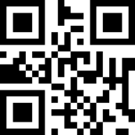
Output multiple prefix

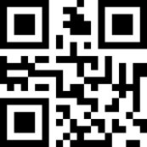
Output multiple prefix&suffix

Hidden characters

Hidden head data
The decoded data can be used to hide the head data, which can be configured to hide any length. If the configured length exceeds the length of the barcode data, all the content of the current barcode can be hidden

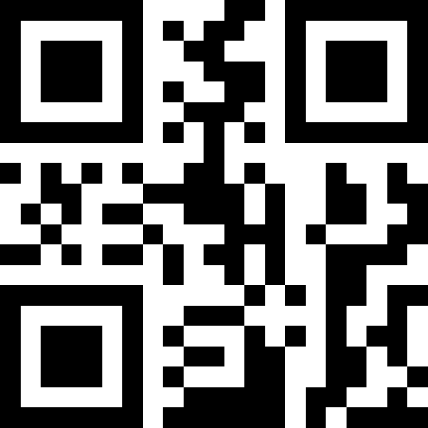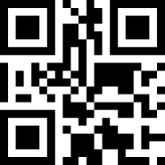
*Prohibit Enable

Setting head data hiding bits
Setting head data hiding bits, range 1-255. Scan the current bar code and then scan the numeric setup code. For example, if you need to hide 16 characters, then scan the sequence number setting code: 0 1 6.
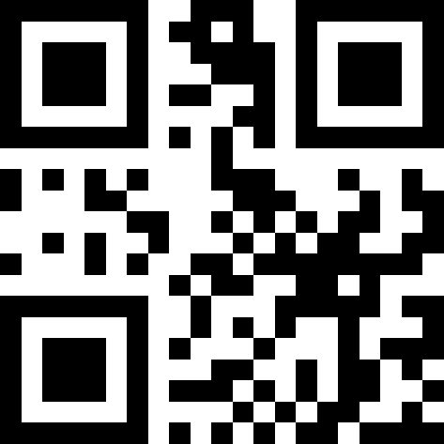
Head data hidden bits

Middle data hiding
The decoded output data is hidden in the middle part, and can be configured at any starting position and length. If the configuration start position exceeds the bar code data length, then the current bar code is not hidden. The length of the configuration exceeds the length of the remaining bar code data, then all bar code data after the start position is hidden

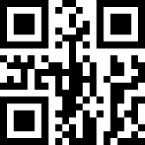
* Prohibit Enable

Set the beginning position of hidden middle data.
Set the beginning position of hidden middle data, range 1-255。scan the current bar code and then scan the digital setup code，For example, to hide data after the third character (the fourth character begins to hide), scan sequentially the number setup code: 0 0 3

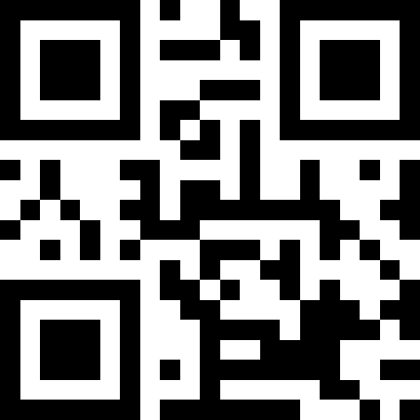
Middle data hiding starting bit

Setting hidden the middle data length
Configure the length of hidden middle part data, ranging 1 -255. Scan the current bar code and then scan the numeric setup code. For example, if you need to hide 16 characters, then scan the sequence number setting code: 0 1 6.

Middle data hiding length

hiding tail data
The data output from decoding is tail data hiding, which can be configured to hide any length of data. If the length of data is longer than the bar code, the current bar code content can be hidden.

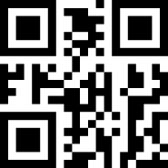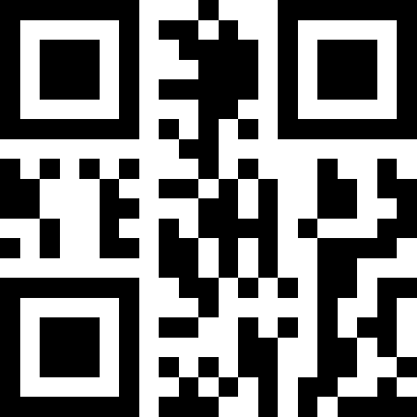
*Prohibit Enable

Setting tail data hiding bits
Set tail data hidden bits, range 1-255. Scan the current bar code and then scan the numeric setup code. For example, if you need to hide 16 characters, then scan the sequence number setting code: 0 1 6.

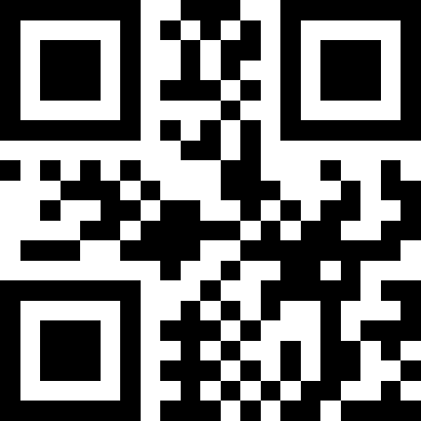
Tail data hidden bits

七、Bar code type enable / disable configuration

One-dimensional code global enable switch
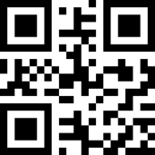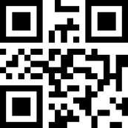
Enable Disable

Two-dimensional code global enable switch
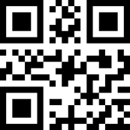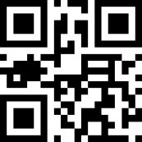
Enable Disable

One dimensional code forward and backward reading
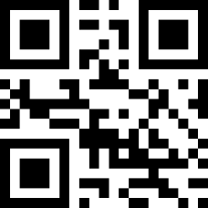
Enable Prohibit

UPC-A
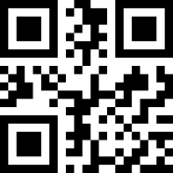
* Enable
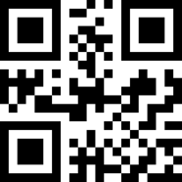
Prohibit
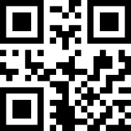
Do not transmit UPC-A check bits
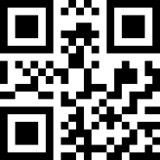
* Transmission UPC-A check bit

UPC-A additional code

UPC-A 2-bit additional code

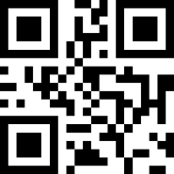
Enable
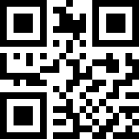
* Prohibit

UPC-A 5-bit additional code
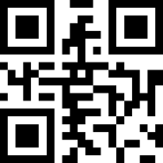
Enable
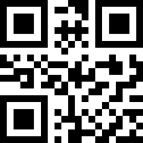
*Prohibit

UPC-A Additional code must be identified.
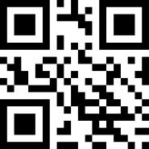
Enable

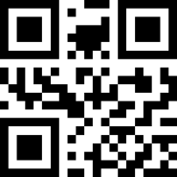
*Prohibit

UPC-E

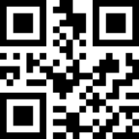
* Enable

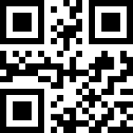
Prohibit
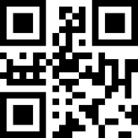
Do not transmit UPC-e check bits
*Transmission UPC-e check bit

UPC-E Additional code

UPC-E Two-bit additional code

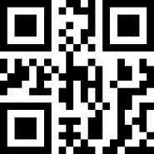
Enable

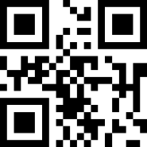
* Prohibit

UPC-E 5-bit additional code
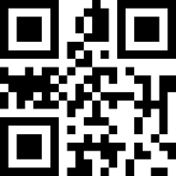
Enable
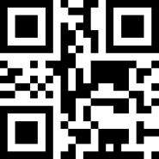
*Prohibit

UPC-E Additional code must be identified.
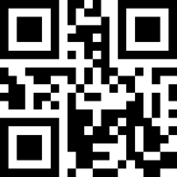
Enable
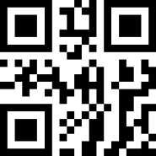
*Prohibit

UPC-E to UPC-A

Enable
^#SC^1020000
* Prohibit

UPC-A to EAN-13

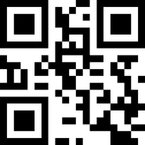
Enable

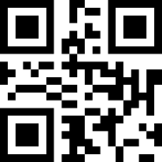
*Prohibit

EAN-8
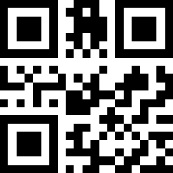
*Enable

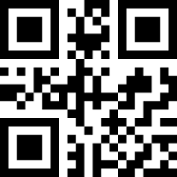
Prohibit

EAN-8 Additional code

EAN-8 2 bit additional code

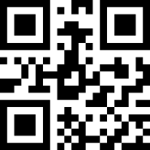
Enable

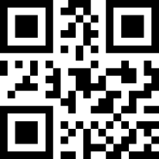
* Prohibit

EAN-8 5 bit additional code
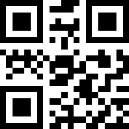
Enable
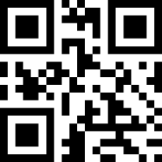
* Prohibit

EAN-8 Additional codes must be identified
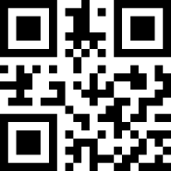
Enable
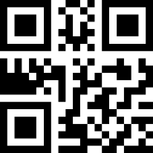
* Prohibit

EAN-13
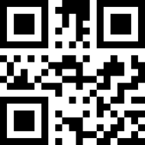
* Enable

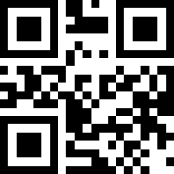
Prohibit

EAN-13 2 bit additional code

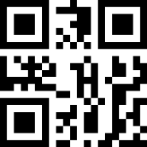
Enable
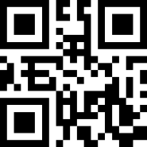
* Prohibit

EAN-13 5bit additional code
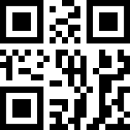
Enable
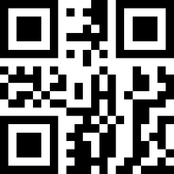
* Prohibit

EAN-13 Additional codes must be identified

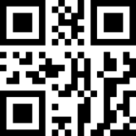
Enable
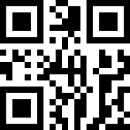
* Prohibit

CODE 128
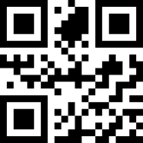
* Enable

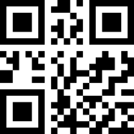
Prohibit

GS1-128
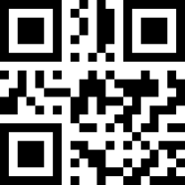
* Enable
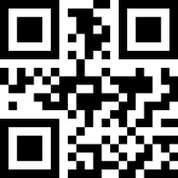
Prohibit

ISBT-128
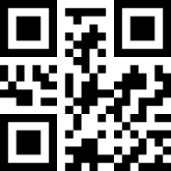
* Enable
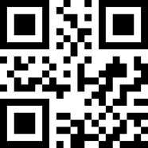
Prohibit

Interleaved 2 of

（1）I 2 of 5 enable
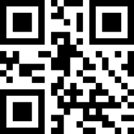
*Enable
Prohibit

（2）Interleaved 2 of 5 Recognition length
The user can set up decoding Interleaved 2 of 5 in a specific length range，
Example: setup can only be decoded by Interleaved 2 of 5 in the 4-20 bit length range. First scan the following code，Then scan the 0 / 4 / 2 / 0 bar code of the digital setting code in turn，Change the selection or cancel an incorrect input setting and scan the cancel bar code in the appendix.
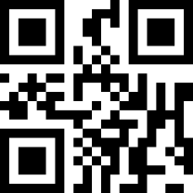
Interleaved 2 of 5 with specific length range
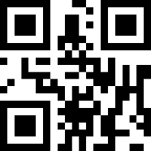
Interleaved 2 of 5 of arbitrary length

（3）Transfer Interleaved 2 of 5 check bit
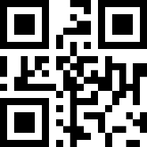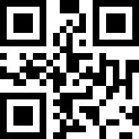
Enable *Prohibit

Matrix 2 of 5

（1）Matrix 2 of 5 Enable/ Prohibit
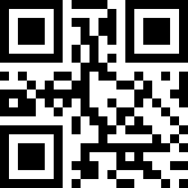
Enable
* Prohibit

（2）Matrix 2 of 5 recognition length
The user can set up decoding the Matrix 2 of 5 in a specific length range. Example: the Matrix 2 of 5 in the 4-20 bit length range can only be decoded to scan the following code first, and then scan the 0,4,2,0 bar code of the digital setting code in turn. Change the selection or cancel an incorrect input setting and scan the cancel bar code in the appendix

.
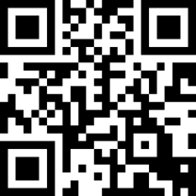
Matrix 2 of 5 in a specific length range
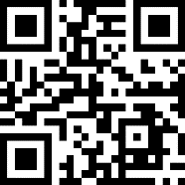
Matrix 2 of 5 in arbitrary length range

（3）Matrix 2 of 5 parity check transmission
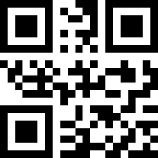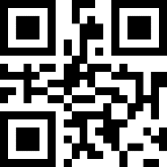
Enable *Prohibit

Industrial 2 of 5

（1）Industrial 2 of 5 Enable/Prohibit
Enable
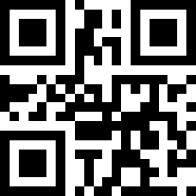
*Prohibit

（2）Industrial 2 of 5 recognition length
The user can set up decoding the Industrial 2 of 5 in a specific length range. Example: the Industrial 2 of 5 in the 4-20 bit length range can only be decoded to scan the following code first, and then scan the 0 / 42 / 0 bar code of the digital setting code in turn. Change the selection or cancel an incorrect input setting, scan the cancel bar code in the appendix。
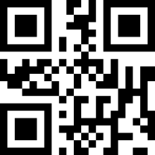
Industrial 2 of 5 in a specific length range
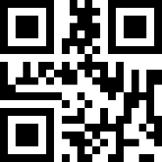
Industrial 2 of 5 in arbitrary length range

Standard 2 of 5

（1）Standard 2 of 5 Enable/Prohibit
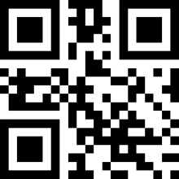
Enable
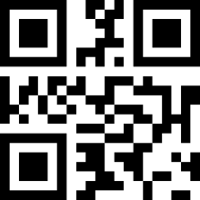
*Prohibit

（2）Standard 2 of 5 read length
The user can set up decoding the Standard 2 of 5 in a specific length range. Example: the Standard 2 of 5 in the 4-20 bit length range can only be decoded to scan the following code first, and then scan the 0 / 42 / 0 bar code of the digital setting code in turn. Change the selection or cancel an incorrect input setting, scan the cancel bar code in the appendix。
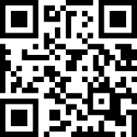
Standard 2 of 5 in a specific length range
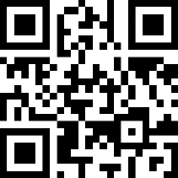

Standard 2 of 5 in arbitrary length range

（3）standard 2 of 5 check bit transmission
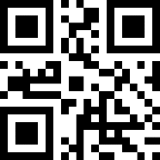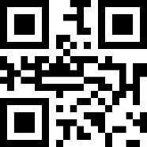
Enable *Prohibit

Code 39

code39 Enable/Prohibit
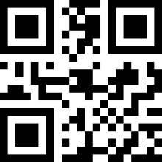
*Enable
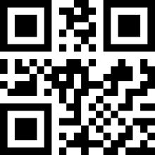
Prohibit

Code39 length
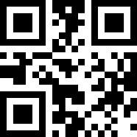
Solvable arbitrary length code39

Code39 check bit
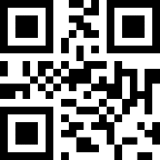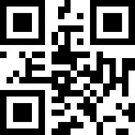
Transmission check bit Non-transmission check bit

Code 39 transfer initiator and Terminator
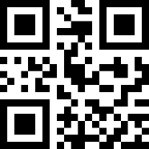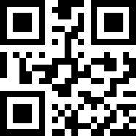
*Prohibit Enable

Code 39 Full ASCII
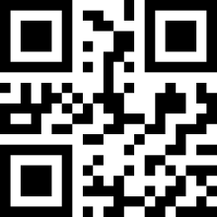
Enable
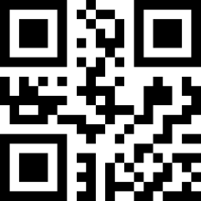
* Prohibit

Code 32

code32 Enable/Prohibit

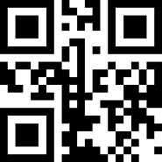
Enable
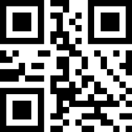
* Prohibit

code32 prefix A
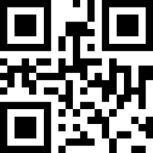
Enable
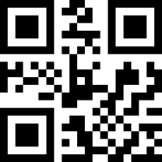
* Prohibit

Code 93
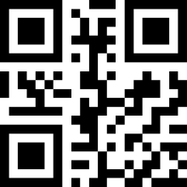
Enable
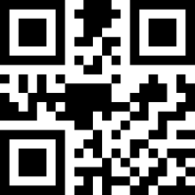
* Prohibit

Code 11

（1） code11 Enable/Prohibit
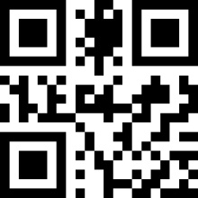
Enable
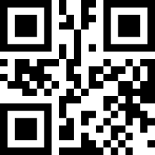
* Prohibit

（2）Check bit transmission
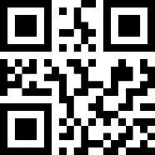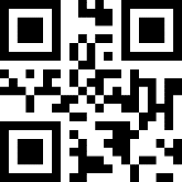
Enable * Prohibit

Codabar
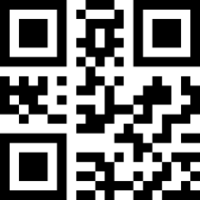
Enable
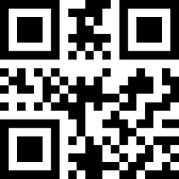
* Prohibit
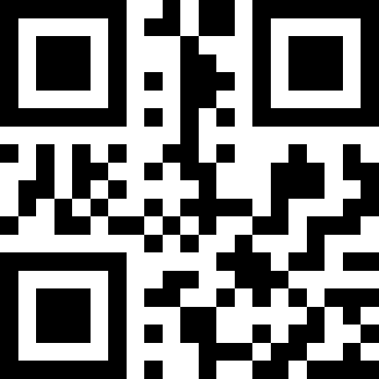
Remove start and stop characters
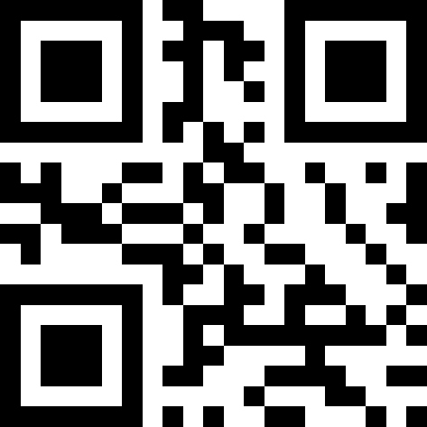
* Allow start and stop characters

PLESSEY
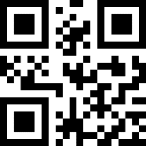
Enable
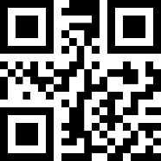
*Prohibit

MSI

MSI Enable/Prohibit
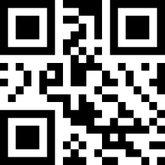
Enable
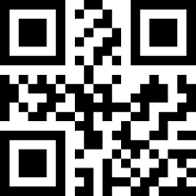
* Prohibit

Length setting
Readable to any length

GS1-Databar

Enable
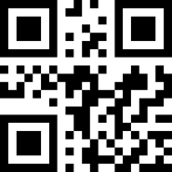
* Prohibit

ITF14
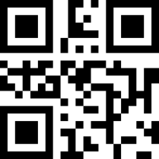
Enable
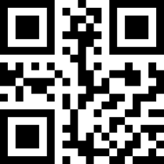
* Prohibit

QR Code

QR code Enable /Prohibit
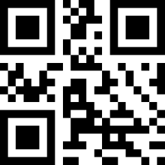
* Enable
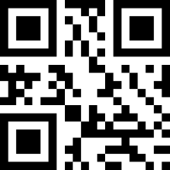
Prohibit

QR codeMulti-code reading
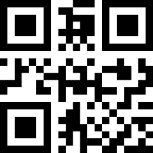
Read only a single code
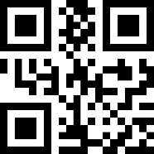
Read only double code
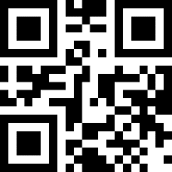
Recognizable single and double code

QR code positive and negative reading
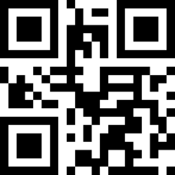
*Read-only positive phase
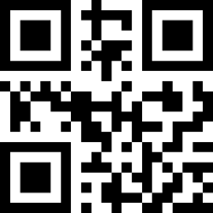
Positive and negative can be read

Data Matrix

Data Matrix enable /Prohibit
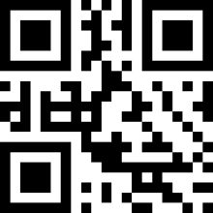
* Enable
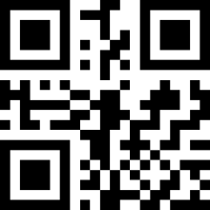
Phohibit

Data Matrix Multi-code reading
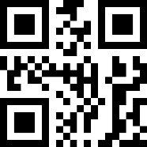
Only read single code
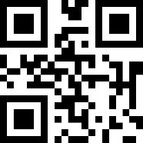
Only read double code
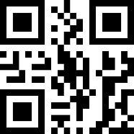
Read single/double code

Data Matrix positive and negative reading
Only read positive code
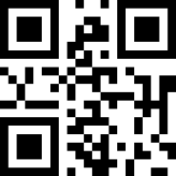
Only read negative code
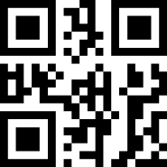
Can read posotive/negative code

PDF 417

PDF417 Enable/Prohibit

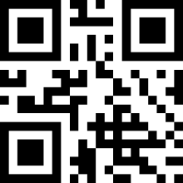
* Enable
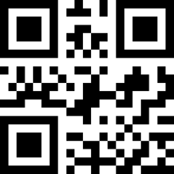
Prohibit

PDF417 multi-code reading
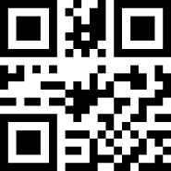
Only read single code
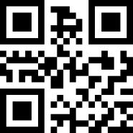
Only read double code
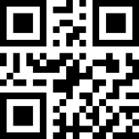
can read single /double code

PDF417 Positive/negative reading
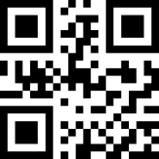
Only read positive
Only read negative
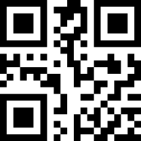
Only positive/negative

Aztec code
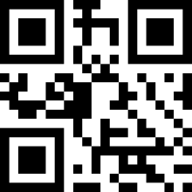
Enable
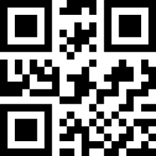
*Prohibit

Maxi code
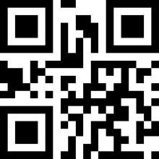
Enable
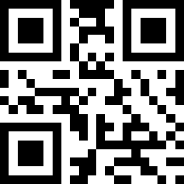
*Prohibit

Hanxing code
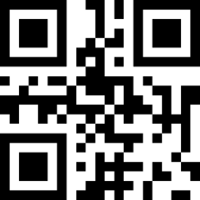
Eable
*Prohibit

Appendix1：Digital setting code
The parameter requires the exact value. Scan the appropriate digital setting code.

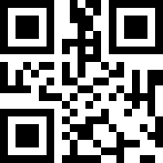
0
1

2

3

4

5

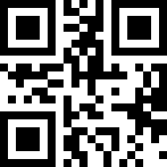
6

7

8

9

Appendix 2：Cancel barcode
To change the selection or cancel an incorrect input, scan the barcode below.
Cancel

Appendix 3：Code ID

Code character | Type of the barcode
A | UPC-A, UPC-E, EAN-8, EAN-13
B | Code 39, Code 32
C | Codabar
D | Code 128, ISBT 128
E | Code 93
F | Interleaved 2 of 5
G | Discrete 2 of 5
H | CODE11
J | MSI, MSI/Plessey
K | GS1-DataBar, /UCC/EAN-128
L | Bookland EAN, Bookland EAN/ISBN
R | GS1 DataBar-14, GS1 DataBar Limited,  GS1 DataBar Expanded, RSS
S | SETUP128
r | PDF417
u | DataMatrix(DM)
q | QR
a | Aztec Code
x | Maxi Code
v | Veri Code
c | HanXin

Appendix 4:Character comparison table
ScanValue | Keyboard value | Scan Value | Keyboard value | Scan Value | Keyboard value
1000 | Null | 1043 | + | 1086 | V
1001 | Keypad Enter | 1044 | , | 1087 | W
1002 | Caps lock | 1045 | - | 1088 | X
1003 | Right Arrow | 1046 | . | 1089 | Y
1004 | Up Arrow | 1047 | / | 1090 | Z
1005 | Null | 1048 | 0 | 1091 | [
1006 | Null | 1049 | 1 | 1092 | \
1007 | Enter | 1050 | 2 | 1093 | ]
1008 | Left Arrow | 1051 | 3 | 1094 | ^
1009 | Horizontal Tab | 1052 | 4 | 1095 | _
1010 | Down Arrow | 1053 | 5 | 1096 | ‘
1011 | Vertical Tab | 1054 | 6 | 1097 | a
1012 | Backspace | 1055 | 7 | 1098 | b
1013 | Enter | 1056 | 8 | 1099 | c
1014 | Insert | 1057 | 9 | 1100 | d
1015 | Esc | 1058 | : | 1101 | e
1016 | F11 | 1059 | ; | 1102 | f
1017 | Home | 1060 | < | 1103 | g
1018 | Print Screen | 1061 | = | 1104 | h
1019 | Delete | 1062 | > | 1105 | i
1020 | tab+shift | 1063 | ? | 1106 | j
1021 | F12 | 1064 | @ | 1107 | k
1022 | F1 | 1065 | A | 1108 | l
1023 | F2 | 1066 | B | 1109 | m
1024 | F3 | 1067 | C | 1110 | n
1025 | F4 | 1068 | D | 1111 | o
1026 | F5 | 1069 | E | 1112 | p
1027 | F6 | 1070 | F | 1113 | q
1028 | F7 | 1071 | G | 1114 | r
1029 | F8 | 1072 | H | 1115 | s
1030 | F9 | 1073 | I | 1116 | t
1031 | F10 | 1074 | J | 1117 | u
1032 | Space | 1075 | K | 1118 | v
1033 | ! | 1076 | L | 1119 | w
1034 | “ | 1077 | M | 1120 | x
1035 | # | 1078 | N | 1121 | y
1036 | $ | 1079 | O | 1122 | z
1037 | % | 1080 | P | 1123 | {
1038 | & | 1081 | Q | 1124 | |
1039 | ‘ | 1082 | R | 1125 | }
1040 | ( | 1083 | S | 1126 | ~
1041 | ) | 1084 | T
1042 | * | 1085 | U

